Session 6:
- SELECT user_id, COUNT(*) AS total_number FROM orders GROUP BY user_id;
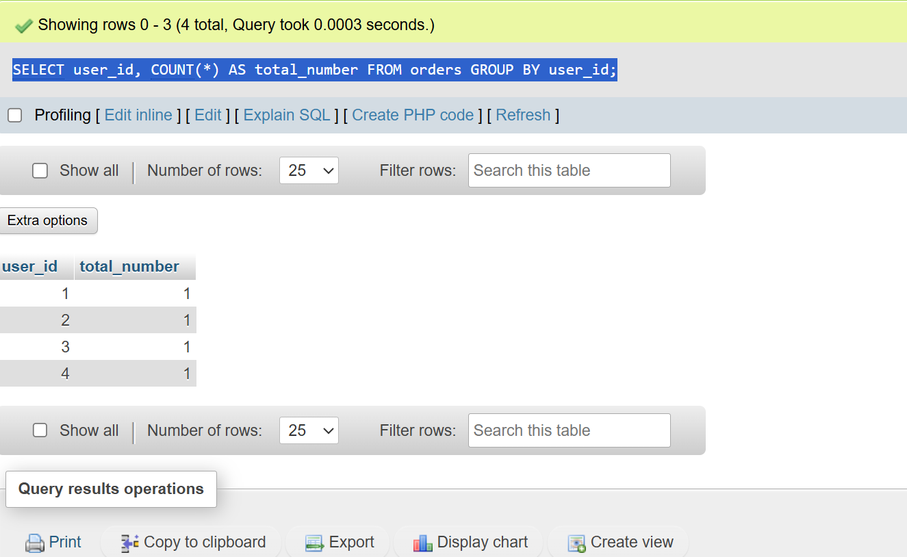

- SELECT name FROM restaurants GROUP BY name HAVING AVG(rating > 4.0);
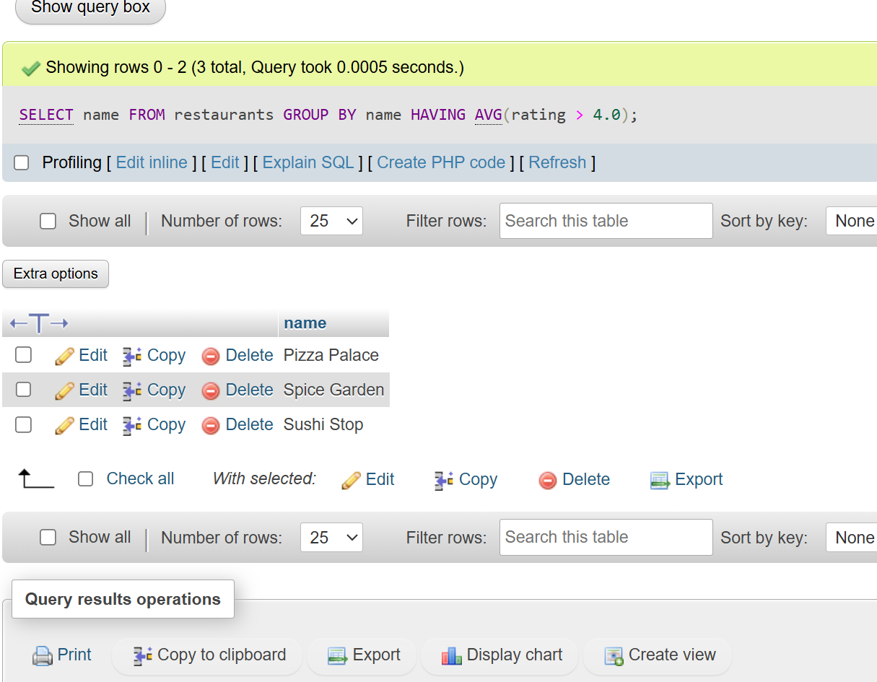

- SELECT * FROM payments WHERE amount IN (SELECT amount FROM payments WHERE amount>2000); 